Año 2 Número 19 marzo 2017

Contenidos de este número

- Curso/Taller sobre Direccion y Desarrollo de Recursos Humanos en Organizaciones Bibliotecologicas y de la Informacion - IIBI UNAM Mexico

El Instituto de Investigaciones Bibliotecologicas y de la Informacion de la Universidad Nacional Autonoma de Mexico le invita cordialmente al
CURSO/TALLER SOBRE DIRECCION Y DESARROLLO DE RECURSOS HUMANOS EN ORGANIZACIONES BIBLIOTECOLOGICAS Y DE LA INFORMACION
Que sera impartido por el Dr. Federico Hernandez Pacheco, Investigador del IIBI UNAM.
Objetivo General:
Identificar las diferentes tendencias y funciones de los recursos humanos en organizaciones publicas o privadas y su aplicacion en organizaciones bibliotecologicas.
Dirigido a:
Profesores, investigadores y profesionales con estudios de licenciatura en Bibliotecologia, Biblioteconomia, Ciencias de la Informacion Documental y areas afines, interesadas y vinculadas con los recursos humanos o manejo de personal.
Temario:
Consulte el temario completo del Curso/Taller en: https://goo.gl/DiRntK
Requisitos:
- Enviar ficha de registro con copia de titulo, cedula profesional, carta de pasante o certificado de estudios en las carreras mencionadas (sin estos requisitos, no se aceptara la inscripcion y el registro al curso).
El Curso/Taller se llevara a cabo del 27 al 31 de marzo de 2017, en la Sala de Seminarios 2 del IIBI, ubicada en la Torre II de Humanidades piso 13, Ciudad Universitaria, Coyoacan, Ciudad de Mexico.
Horario: 16:00 a 20:00 hrs.
Duracion: 20 horas
CUPO LIMITADO. Se entregara constancia de asistencia.
Cuota de recuperacion:
UNAM: $1,700.00 M.N.
Otras Instituciones: $2,100.00 M.N.
Inscripciones abiertas. Obtenga el formato de inscripcion disponible en: http://iibi.unam.mx/informesec.html e inscribase por correo electronico (no olvide anexar copia de titulo, cedula profesional, carta de pasante o certificado de estudios, de lo contrario no se le inscribira al curso).
Le solicitamos de la manera mas atenta hacer extensiva esta invitacion entre el personal de su comunidad, asi como con amigos e interesados.
INFORMES E INSCRIPCIONES:
Lic. Sarah Iliana Gonzalez Comi
Depto. de Difusion y Educacion Continua
Instituto de Investigaciones Bibliotecologicas y de la Informacion / UNAM
Tels: (52-55) 562-30352 y 30193
Fax: (52-55) 562-30375
sarahgc@iibi.unam.mx
http://iibi.unam.mx

- Trump’s Budget Proposal Eliminates Funding For IMLS, NEA, NEH, CPB, and More
Filed by Gary Price on March 16, 2017
Note: We plan to update this post with additional reports, comments/reactions. and other materials as they become available.

Full Text of Institute of Museum and Library Services Issues Statement om the President’s Proposed FY 18 Budget
Institute of Museum and Library Services Director Dr. Kathryn K. Matthew released the following statement on the President’s proposed FY 2018 budget, which includes elimination of the Institute of Museum and Library Services.
Since its inception 20 years ago, the grants and programs the Institute of Museum and Library Services has administered have provided critical support that has enabled museums and libraries across the country to make a tremendous difference in their communities. The institutions we serve provide vital resources that contribute significantly to Americans’ economic development, education, health, and well-being whether by facilitating family learning and catalyzing community change or stimulating economic development through job training and skills development. Our agency’s support enables museums and libraries to offer learning experiences for students and families as well as increase care for and access to the nation’s collections that are entrusted to museums and libraries by the public.
We’ve invested in rural and smaller communities by supporting basic infrastructure and the development of libraries as local community hubs for broadband connectivity and digital literacy training, which has helped hundreds of residents gain job-related skills and, in many cases, find employment. In summary, our grants and programs support libraries and museums as essential contributors to improving Americans’ quality of life.

http://www.infodocket.com/2017/03/16/trumps-federal-budget-proposal-eliminates-funding-for-imls-nea-neh-cpb-and-more/

- Harvard Business Alumni Offer SFPL Pro Bono Consulting
By Lisa Peet on March 2, 2017 Leave a Comment
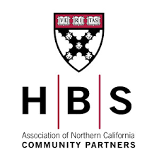While many public libraries could benefit from business counsel from a team of experts, professional consulting services are not always in the budget, even for larger systems. But recently San Francisco Public Library (SFPL) had the opportunity to do just that, after it was selected to receive pro bono consultation from a team of Harvard Business School alumni.
For several months beginning in November 2016, SFPL representatives met with a team of professionals from Harvard Business School (HBS) Community Partners, a volunteer group of alumni, to help the 27-branch system define its needs and plan for a digitally inclusive future. Working with the Future of the Libraries Forum, the team assembled by SFPL city librarian Luis Herrera (LJ’s 2012 Librarian of the Year), HBS Community Partners assembled a benchmark survey of peer urban libraries and brought in private industry models such as HBS professor Clayton Christensen’s disruptive innovation theory principles, that the library could study to identify best practices for serving the needs of its rapidly changing community.

http://lj.libraryjournal.com/2017/03/managing-libraries/harvard-business-alumni-offer-sfpl-pro-bono-consulting/

- A Practical Guide to Choosing the Right Furniture for Your Library

Download a case study about a program that will allows you to design and build a more space for your library

A Practical Guide to Choosing the Right Furniture for Your Library  What integral elements of design and construction create the most effective library furniture for contemporary libraries? Because the answer is not always obvious, AGATI has compiled all dimensions of our experience building furniture for academic and public libraries into a short paper just for librarians looking to create the best learning environments possible for their patrons.  Click Here to read the case study. | SPONSORED BY:

5.
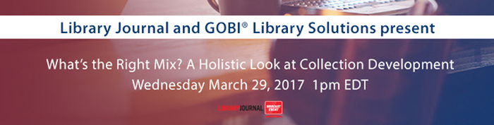

What’s the Right Mix? A Holistic Look at Collection Development
Wednesday, March 29, 2017
1-2 PM ET, 10-11 AM PT
Acquisition librarians and those charged with collection development responsibilities have a wide range of options for acquiring content. Recent years have seen the rise of acquisition models such as DDA to help librarians acquire content based on user demand.
But with more publishers removing front list titles from DDA and costs increasing with changes in triggers, has demand driven acquisition or other usage-based models lived up to the promise of saving library budgets? How do these models and others come into play in a balanced collection development strategy?

http://mediasource.actonservice.com/acton/ct/10574/s-1084-1703/Bct/l-00ab/l-00ab:22523/ct1_5/1?sid=TV2%3ABlrb9KUln
- Mesa Redonda: Normalizacion de la informacion en los repositorios institucionales y nacional de investigacion: experiencias en Argentina y Mexico - IIBI UNAM Mexico

El Instituto de Investigaciones Bibliotecologicas y de la Informacion de la Universidad Nacional Autonoma de Mexico, se complace en invitarle a la
MESA REDONDA: NORMALIZACION DE LA INFORMACION EN LOS REPOSITORIOS INSTITUCIONALES Y NACIONAL DE INVESTIGACION: EXPERIENCIAS EN ARGENTINA Y MEXICO
Actividad del Seminario de Investigacion Metadatos, coordinado por el Dr. Ariel Alejandro Rodriguez Garcia, Investigador del IIBI / UNAM.
Participan:
- Dr. Victor Gerardo Carreon Rodriguez
Director Adjunto de Planeacion y Evaluacion / CONACYT
- Paola A. Azrilevich
Sistema Nacional de Repositorios Digitales / Ministerio de Ciencia, Tecnologia e Innovacion Productiva, Argentina
Coordina / Modera:
Dra. Alma Rivera Aguilera
Universidad Iberoamericana / Miembro del Seminario de Investigacion Metadatos
La Mesa Redonda se llevara a cabo el miercoles 22 de marzo de 2017, a partir de las 12:00 hrs., en la Sala de Seminarios del IIBI, ubicada en la Torre II de Humanidades, piso 13, Ciudad Universitaria, Ciudad de Mexico.
Entrada Libre. Cupo Limitado.
Transmisión en vivo por el canal del IIBI en YouTube: https://www.youtube.com/CUIB100

- Meet the Candidates: ALA President 2018–19
By Lisa Peet
Voting for the American Library Association (ALA) 2018–19 presidential campaign opened March 13, and ALA members can cast their ballots through April 5. Results will be announced April 12.
This year’s candidates have experience working in a range of library types. Loida Garcia-Febo, an international library consultant, is a former public librarian and president of Information New Wave in Brooklyn, NY, a nonprofit organization working to bring information access to underserved populations. Terri Grief is a school librarian at McCracken County High School in Paducah, KY. Petition candidate Scott Walter is university librarian, DePaul University, Chicago. LJ has invited the candidates to weigh in on some key issues pertaining to ALA and librarianship; more information can be found on ALA’s Election Information page.
1. What do you think is the most important characteristic for the new ALA Executive Director (ED) to have? What mistakes should they avoid?
Loida Garcia-Febo  Loida Garcia-Febo: We need someone at the helm who understands libraries, shares our values, mission, principles, and our experiences, and stands for our core values including intellectual freedom, social responsibility, diversity, access, professionalism, and democracy. We also need an Executive Director with experience in government and municipal networks, managing large organizations, and not-for-profit experience. | 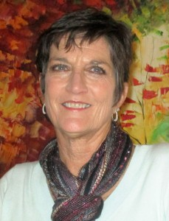  Terri Grief  Terri Grief: We need a team builder to unite the association. An often heard complaint from members is that the association is made up of silos and we have to be united to face the issues that threaten libraries and intellectual freedom. Keith has been a great leader for ALA and school librarians became more a part of “big” ALA under his leadership. I want every division and unit to feel this same care from ALA. The person has to be a listener. The ability to look at the big picture and the ability to share leadership is vital. There is a strong staff that will support the ED and he or she will need to trust and depend on them.
Scott Walter: There are a number of professional competencies and personal dispositions that we have seen already discussed as critical for the new ALA ED, but I think the most important characteristics, especially in the current environment, are: 1) a commitment to the core values of the profession; 2) an appreciation for the professional expertise represented by ALA members; and, 3) a bias toward action.

http://lj.libraryjournal.com/2017/03/people/meet-the-candidates-ala-president-2018-19#_
- Best Databases of 2016
BY LJ REVIEWS ON MARCH 2, 2017 LEAVE A COMMENT
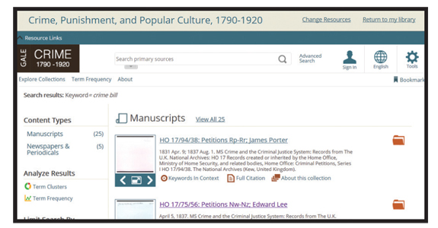
Many databases and digital reference products were reviewed in 2016. The following are the cream of the crop.
ACI Scholarly Blog Index (ASBI)
ACI Information
aci.info/scholarly-blogs
ACI Scholarly Blog Index is a distinctive database that connects users to social media and blog postings created by experts in a variety of academic and research fields. This resource boasts over 10,000 scholarly blogs, with more than one million posts. Specialists in each topic or field selectively curate the collection of sources, ensuring that visitors can find blogs with active content in their field of study. Users will enjoy the options available for collecting and viewing relevant results. When selecting an article to view, a resulting page gives the option of either a summary or full text, as well as a list of features, including publication metadata and author details (education, position, societies, and awards). This provides a thorough introduction to the author’s area of expertise. With the plethora of social media and blog posts published daily, ASBI will appeal to those seeking quality, relevant content that meets their academic needs. The extensive topics and curated articles create a worthwhile resource to support the academic journal indexes already available. (LJ 9/1/16)—Katie McGaha
http://reviews.libraryjournal.com/2017/03/best-of/best-databases-of-2016/

