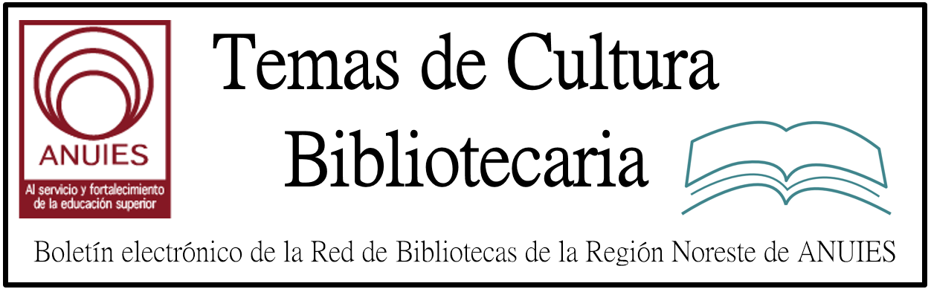

Año 2 Número 17 marzo 2017

Contenidos de este número

Consortium of Funders Announce Support to Explore the Value, Feasibility of Establishing Central Service for Preprints
Filed by Gary Price on February 13, 2017
From a Wellcome Trust Blog Post:
For more than 25 years, researchers in disciplines such as high-energy physics and mathematics have been able to access the very latest research findings in the online repository known as arXiv (pronounced ‘archive’).
Here, researchers deposit their preprints – complete and public drafts of scientific documents, not yet certified by peer review – to:
- ensure their findings are quickly and widely disseminated
- establish priority of their discoveries
- invite feedback and discussion to help improve the work.

http://www.infodocket.com/2017/02/13/consortium-of-funders-announce-support-to-explore-the-value-feasibility-of-establishing-central-service-for-preprints/

- Curso: La Gestión Documental en el ambiente del gobierno abierto - IIBI UNAM México

El Instituto de Investigaciones Bibliotecologicas y de la Informacion de la Universidad Nacional Autonoma de Mexico le invita cordialmente al Curso: La Gestion Documental en el ambiente del gobierno abierto, que sera impartido por la Dra. Brenda Cabral Vargas, Investigadora del IIBI UNAM.
Justificacion:
La relevancia del curso radica en que tiene un alcance amplio debido a que la gestion documental de archivos se relaciona con una gran cantidad de temas como: la transparencia, el acceso a la informacion publica y la rendicion de cuentas. Asi como la importancia del tema tanto en la agenda nacional como en la internacional, del que este tema forma parte. Con ello se preparan profesionales que puedan desempenar funciones en el ambito de las TIC´s y la gestion tecnologica documental.
Objetivo general:
El participante identificara y considerara los aspectos fundamentales para realizar proyectos que le permitan gestionar los documentos en los distintos tipos de archivos.
Temario:
Consulte el temario completo del Curso en: https://goo.gl/1v4Qfr
Dirigido a:
Profesores, investigadores y profesionales con estudios de licenciatura en Bibliotecologia, Biblioteconomia, Ciencias de la Informacion Documental y areas afines, interesados en la gestion de archivos.
Fecha, horario y lugar:
El Curso: “La Gestion Documental en el ambiente del gobierno abierto” se llevara a cabo del 13 al 17 de marzo de 2017, de 9:00 a 13:00 hrs.

New Ideas in Collection Development & Merchandising

Revamp Your Strategy to Engage Readers and Spark Circulation
March 8–29, 2017
Live Sessions on Wednesdays at 1:00 PM ET: March 8, 15, 22 & 29
REGISTER
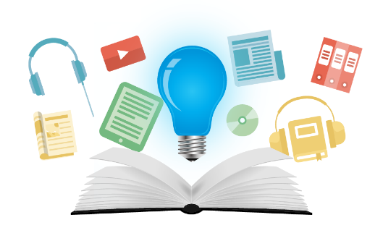
Learn real techniques for increasing your library’s circulation and expanding your staff’s capacity for readers advisory in this four week online course. You will attend weekly guest speaker sessions via webcast and build your collection development strategy through weekly assignments. A dedicated advisor will provide you with one-on-one feedback for your plan within an online discussion group, where you will share resources and best practices with a group of peers from across the country.
Participants will complete weekly assignments that help them build a new collection development strategy and staff training plan to expand their reach in readers’ advisory.

http://learn.libraryjournal.com/courses/new-ideas-in-collection-development-merchandising/?utm_source=sljeventalerts&utm_medium=email&utm_campaign=collectiondevelopment

How Wide is the Gap Between Librarians and Faculty? (Infographic)
In 2016, McGraw-Hill surveyed more than 1,000 librarians and faculty members to learn more about their views of both community and academic libraries. Participants were asked questions regarding library use, budget, technology, and how they see libraries serving their communities, whether they are students or community library patrons. The survey results, found in The Changing Role of Libraries reveal that librarians and faculty are not aligned as to what they believe makes libraries valuable. The following infographic explains the factors that widen the gap between librarians and faculty:
http://mcgrawhillprofessionalblog.com/wide-gap-librarians-faculty-infographic/

DIY Usability: First-Click Testing | The User Experience
By Emily Mitchell & Brandon West on February 16, 2017 Leave a Comment
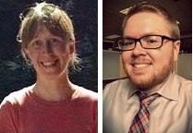Although every library would benefit from running usability studies, not every library has a dedicated staff available to conduct those studies. Anecdotally, librarians seem to feel incapable of undertaking usability studies for reasons including time, budget, and expertise.
We all may be jealous of the libraries that have dedicated usability/user experience (UX) librarians, but that doesn’t mean the rest of us can’t conduct successful, worthwhile testing that leads to website improvements. There are plenty of quick usability tests that can be run with just a little time and even less expertise.
First-click testing offers a way to gain insight about an interface in order to make design decisions based on data rather than on opinion or anecdotal evidence. The concept is simple: show patrons a library web page and give them an imaginary task to complete. Then ask them to show you where they would click to get started.
For example, a task for college students may include asking them where they would find journal articles related to sociology for their Social Work 101 class. After students make their first click, the test is complete. Talk about simple!
http://lj.libraryjournal.com/2017/02/digital-resources/diy-usability-first-click-testing-the-user-experience/#_

- 3a Sesion del Seminario de Investigacion Informacion y Comunidades Indigenas - IIBI UNAM / UIIM Mexico
1
El Instituto de Investigaciones Bibliotecologicas y de la Informacion (IIBI) de la Universidad Nacional Autonoma de Mexico (UNAM), en colaboracion con la Universidad Intercultural Indigena de Michoacan (UIIM) y con el apoyo de la Escuela Nacional de Estudios Superiores Unidad Morelia (ENES Morelia), el Laboratorio Nacional de Materiales Orales (LANMO) y el Centro de Cooperacion Regional para la Educacion de Adultos en America Latina y el Caribe (CREFAL), le invitan cordialmente a la
3ª Sesion del SEMINARIO DE INVESTIGACION INFORMACION Y COMUNIDADES INDIGENAS:
Fortalecimiento, organizacion y preservacion de la informacion originaria: bases para construir un modelo de biblioteca indigena de la comunidad Purepecha
(Programa UNAM DGAPA PAPIIT - IG400417)
29, 30 y 31 de marzo de 2017
COORDINADOR:
Dr. Cesar Augusto Ramirez Velazquez, Investigador del IIBI / UNAM

Why Med School Students Tutor at My Library
By Lisa K. Brandenburg 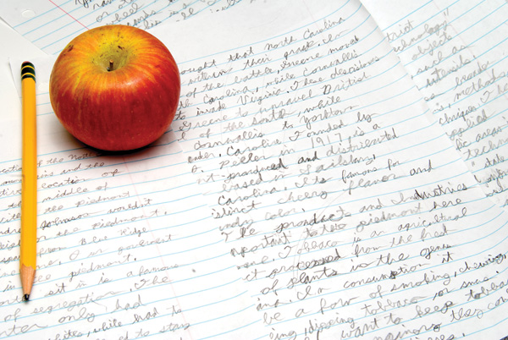
Tutor Time, our library partnership with students from the Cooper Medical School of Rowan University (CMSRU), began in September 2013, when I was a youth services librarian at the Ferry Avenue Branch of the Camden County (NJ) Library. Brian McCauley, a CMSRU student, contacted me about having medical school students reading to kids as part of CMSRU’s curriculum of providing community service to Camden residents.
In the past, we had tried to partner with a local university’s education students. But as their workload intensified and class schedules changed, it was hard to maintain consistent programming. The university withdrew.
It was particularly busy in our branch when McCauley arrived for our meeting. Kids were asking for help with algebra and geometry while I was answering the phone, assisting in the computer lab, and fielding requests for snacks. I asked Brian on the spot if he could help the kids with their math problems. He did, and the next day he proposed the tutoring initiative.

http://www.slj.com/2017/02/programs/why-med-school-students-tutor-at-my-library/#_

