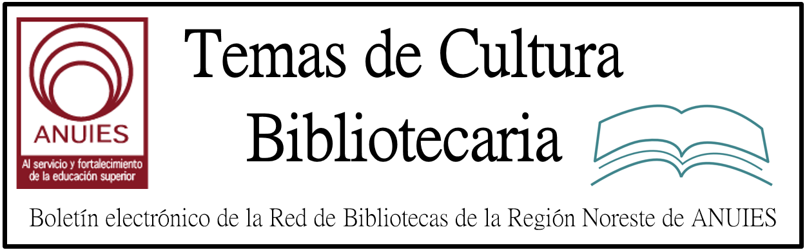

Año 2 Número 16 Febrero 2017

Contenidos de este número

Papel de los archivos fotográficos de Derechos Humanos en la memoria colectiva
Sonia Natalia Cogollo-Ospina ; Luis Carlos Toro Tamayo ;
Revista Interamericana de Bibliotecología 2016, 39 (1)

http://www.redalyc.org/articulo.oa?id=179043373008

Hi-Tech Library Project in UK Spawns Book Promoting ‘New Ways To Work With Readers’
Filed by Gary Price
From The Guardian:
A project to reimagine libraries involving zombies, young people, a group of tech-savvy artists and a nine-hour interactive broadcast beamed around the world, has sparked a book that organisers hope will inspire library authorities.
The book, A Place Free of Judgement, is a collaboration between the performance art group Blast Theory and the writer Tony White, who put together a series of events under the same title in local libraries in Worcestershire and Staffordshire last year. Groups of young people were trained over six months in presentational, audiovisual and writing skills before taking control of their local library for a broadcast to a worldwide audience via an interactive live stream.

http://www.infodocket.com/2017/02/13/hi-tech-library-project-in-uk-spawns-book-promoting-new-ways-to-work-with-readers/

Los usos de la red social Facebook por parte de bibliotecas universitarias argentinas. Reflexiones en torno a las dinámicas comunicativas en la Web 2.0
Claudia Nora Laudano ; María Cecilia Corda ; Javier A. Planas ; María Inés Kessler ;
Revista Interamericana de Bibliotecología 2016, 39 (1)

http://www.redalyc.org/articulo.oa?id=179043373004

4.
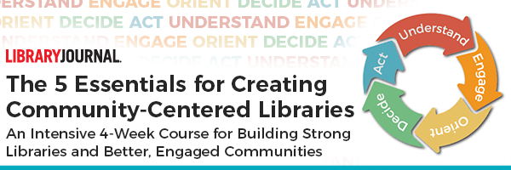
Registration now open for
The 5 Essentials For Creating Community-Centered Libraries
We are excited to announce that David Bendekovic, President of The B. A. David Company and Program Developer and Lead Instructor at the Pennsylvania Library Association Academy For Leadership Studies will now be leading this intensive 4-weekonline course for building stronger libraries and better, engaged communities.
Join peers and leading library directors doing innovative work to learn why and how librarians are taking advantage of powerful community engagement tools.
Download the Course Agenda
Over four weeks, you will have direct access to live speakers via webcasts and be challenged to complete assignments and field research that will help you discover and contribute to your community through outreach, relationship-building, and meaningful programming.

Just Announced: “Ambra, the PLOS Journal Publishing Platform, is Open Again”
Filed by Gary Price on February 13, 2017
From the PLOS Tech Blog Post by Patrick Polischuk:
This isn’t the first time Ambra was available to those looking for a journal publishing platform.
Under continuous development since 2009, Ambra was a monolithic Struts webapp offered as open source since its beginning. In 2012, PLOS began a project to re-architect Ambra as a service-oriented, multi-component stack.
PLOS has been actively using, testing, and improving these new components in its journal platform since 2013, and in early 2016 we replaced the legacy Ambra webapp in its entirety. Having sorted through some minor license incompatibilities and put together documentation and quickstart guides, we’re proud to release Ambra under the MIT License.

http://www.infodocket.com/2017/02/13/just-announced-ambra-the-plos-journal-publishing-platform-is-open-again/

Experiencia exploratoria con Maestros de Apoyo del Plan Ceibal (Uruguay) como insumo para la creación de un Modelo de Alfabetización en Información
Lucía Baica Preyones ; Magela Cabrera ; Alicia Diaz Costoff ; Sandra García-Rivadulla ; María Gladys Ceretta ;
Revista Interamericana de Bibliotecología 2016, 39 (1)

http://www.redalyc.org/articulo.oa?id=179043373003

Explore the future of library science with Drexel
Drexel’s online MSLIS program offers you the opportunity to explore every nook of librarianship as you begin or continue your career in information and library science.
Whether you’re a die-hard bibliophile or a coding wizard – or even if you’re not sure yet – Drexel’s online MSLIS program offers five concentrations to help you find your passion and success after graduation.
Online MSLIS alumna and ALA Emerging Leaders award recipient Tiffany Chow discovered her ambition was in research and archival studies. “The online MSLIS program at Drexel was about finding inspiration and implementing new ideas,” said Chow, now a research librarian at a university in San Diego.
The possibilities of a career as a librarian – whether it be in a library or a non-traditional role – are absolutely endless, and Drexel’s online MSLIS program will help you find a path that inspires you!
Learn More

http://duo.online.drexel.edu/mslis/?campaign=141345&ccid=141345&wt.mc_id=141345&utm_source=Library+Journals%2C+LLC&utm_medium=email&utm_content=MS+in+LIS&utm_campaign=141345

