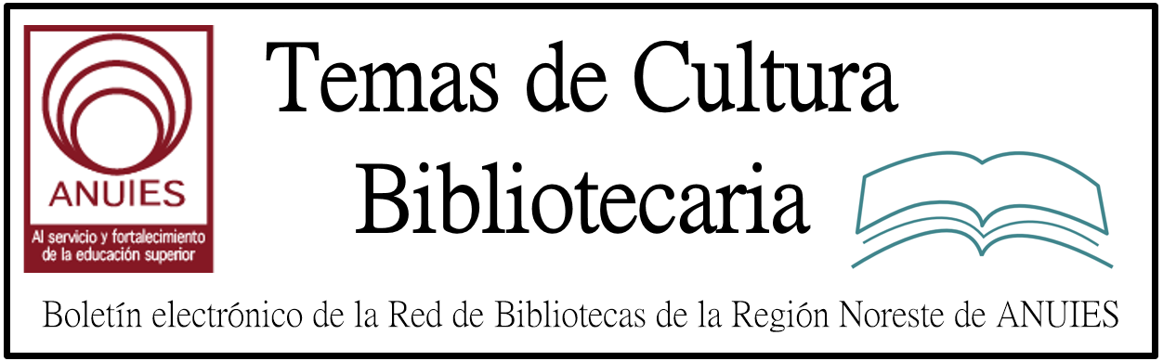

Año 2 Número 15 Febrero 2017

Contenidos de este número

L 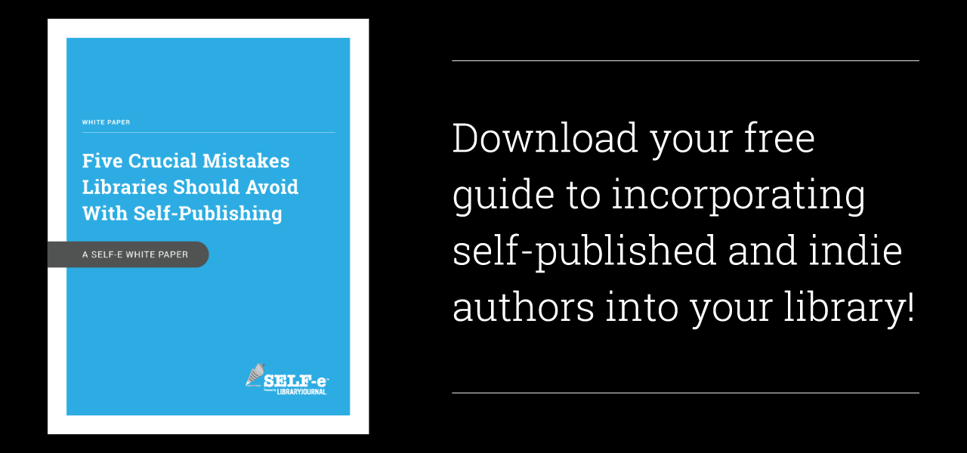ibrary Journal and BiblioBoard partner to bring you SELF-e, your library's solution to becoming a community center for local author discovery. SELF-e's mission is to make your library a hub for patrons to connect with indie and self-published authors in your community.
If you're ready to learn more about the best practices for supporting local indie authors, SELF-e is proud to provide you with this complimentary download of "Five Crucial Mistakes Libraries Should Avoid with Self-Publishing: A SELF-e White Paper."
You can expect more evidence-based insights like these from SELF-e's white papers throughout 2017. We look forward to helping your library make informed decisions about the best ways to connect local authors and patrons at your library.

DOWNLOAD YOUR FREE WHITE PAPER

2. From Pilot to Permanent | Innovation
By Jennifer Koerber on February 13, 2017 Leave a Comment
One of the most effective ways to test and evaluate a new program or service is to conduct a pilot project, but how do you scale up from there? How do you translate the small successes into sustainable, permanent additions to your library?
The example of the Clinton-Macomb Public Library (CMPL), near Detroit, can shed some light on the subject. In 2015, CMPL was selected as one of some 60 communities to participate in the White House’s ConnectED Library Challenge, the goal of which was to connect every public school student in town to library resources, particularly ebooks.
Jennifer Koerber led the “Coding as a Practical Library Program” session during Library Journal‘s Spring 16′ coding online course. Featuring up-to-the minute content and expertise on launching a coding program in your library and promoting digital literacy in your community, the next Coding Program Workshop starts February 28, 2017.
CMPL interpreted the challenge ambitiously, deciding that its goal was not just to provide electronic resource access to every K-12 student in the service area but also to get students to use the library’s resources. To start with, CMPL worked with a single school district in the first pilot, issuing virtual library cards to the 10,000 students who didn’t have a physical card; within nine months, 1,000 of those students had upgraded to a full-service card. Extending to a second school district added another 10,700 students, and a third increased the total number by 3,000 more. Students and teachers were using online resources. For example, visits to Biography in Context rose from 27 to 803 in one year. Yet CMPL doesn’t plan to stop there. According to Larry Neal, CMPL director, “We’ve made it a goal to expand the program to our entire cooperative of 22 libraries, serving 150,000 students (ten percent of Michigan’s total).”

http://lj.libraryjournal.com/2017/02/lj-in-print/from-pilot-to-permanent-innovation/

3. Métodos de enseñanza de la bibliotecología
Por Josefa E. SAROK
con un estudio preliminar de Ricardo .Nas.rzf

http://unesdoc.unesco.org/images/0013/001355/135585so.pdf

Libraries Preserve Protest Posters
By M. Catherine Hirschbiel on February 9, 2017 1 Comment
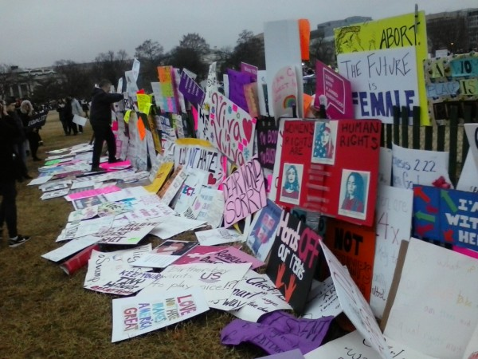
Signs from the Washington, DC, march
Photo credit: Julia Kedge
In the wake of the record-breaking attendance at the January 21 Women’s March on Washington, and sister marches in over 60 cities on all seven continents, social media reported that protesters were abandoning their signs after the event. Not all of those were destined for the recycling bin, however: archivists in several cities came out to collect and preserve them. The signs, many homemade and bearing witty slogans, were a highlight of the marches which, according to the organizers’ website, aimed to “send a bold message to our new government on their first day in office, and to the world that women’s rights are human rights. We stand together, recognizing that defending the most marginalized among us is defending all of us.”
The events drew such large crowds that, in some cities, the actual “march” part of the rally had to be cancelled because the entire route was full of protesters.
http://lj.libraryjournal.com/2017/02/academic-libraries/libraries-preserve-protest-posters/

4. Los usos de la red social Facebook por parte de bibliotecas universitarias argentinas. Reflexiones en torno a las dinámicas comunicativas en la Web 2.0
Claudia Nora Laudano ; María Cecilia Corda ; Javier A. Planas ; María Inés Kessler ;
Revista Interamericana de Bibliotecología 2016, 39 (1)

http://www.redalyc.org/articulo.oa?id=179043373004

5. Louisville Library Workers Champion Preferred Pronoun Badges
By Lisa Peet
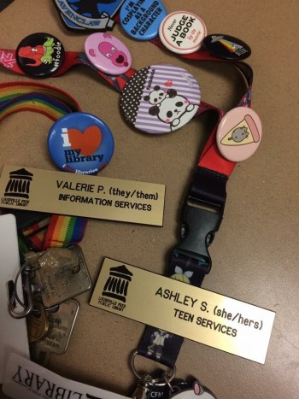
New Louisville Free Public Library staff pronoun badges
Photo credit: Angela Berry
Six months after librarian Valerie Pfister was told by administrators at Louisville Free Public Library (LFPL) that wearing a preferred pronoun button was a dress code violation, the library has honored its promise to list preferred pronouns on the library-issued name badges of any employee who requests it. The library also agreed to update the city’s Transgender 101 training with Pfister’s help, and offer it to any library employee who wished to take it.

http://lj.libraryjournal.com/2017/02/diversity/louisville-library-workers-champion-preferred-pronoun-badges/

6. Los repositorios como herramienta para la recuperación del patrimonio bibliográfico: el caso de seis bibliotecas públicas municipales del departamento de Antioquia
Wilson Castaño Muñoz ; María Camila Restrepo ;
Revista Interamericana de Bibliotecología 2016, 39

http://www.redalyc.org/articulo.oa?id=179043373007

7. In Call for Early STEM Learning, Libraries Cited as Potential ‘Charging Stations’
By Linda Jacobson on February 9, 2017 Leave a Comment
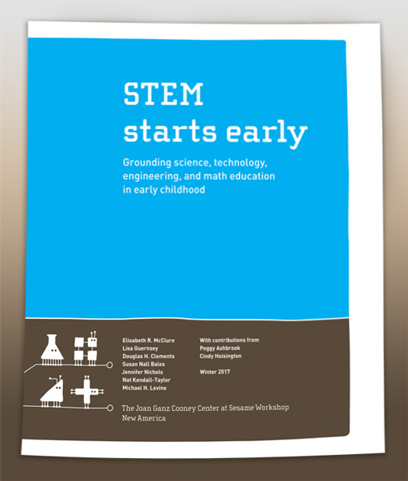
Young children are surrounded by STEM learning opportunities both at home and in early childhood classrooms. But parents need support to help their children in these subject areas, and teachers require “more robust training and professional development” to weave STEM throughout the curriculum, states a new report supported by the National Science Foundation.

http://www.slj.com/2017/02/industry-news/in-call-for-early-stem-learning-libraries-cited-as-potential-charging-stations/

