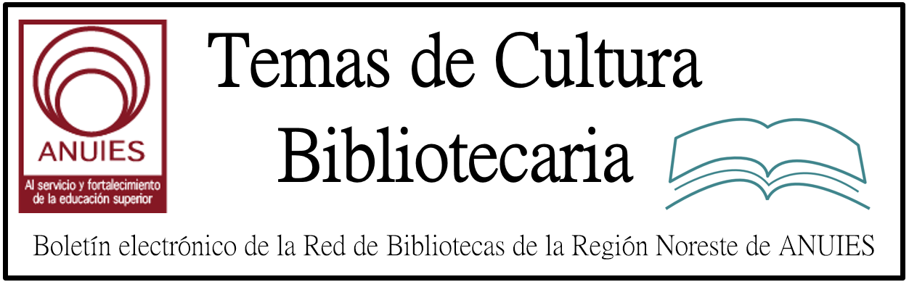

Año 2 Número 14 Febrero 2017

Contenidos de este número

El Instituto de Investigaciones Bibliotecologicas y de la Informacion, en colaboracion con la Escuela Nacional de Estudios Superiores Unidad Morelia, a traves de la Licenciatura en Administracion de Archivos y Gestion Documental y la Unidad de Documentacion Cientifica, de la Universidad Nacional Autonoma de Mexico, le invitan cordialmente al
XII SEMINARIO DE INVESTIGACION SOBRE USUARIOS DE LA INFORMACION
El fenomeno de las necesidades de informacion en diferentes comunidades: archivos
13 al 17 de marzo de 2017
COORDINADORES:
- Dr. Juan Jose Calva Gonzalez - Investigador del IIBI / UNAM
- Lic. Mauricio Anaya Rivas - Responsable de la Unidad de Documentacion Cientifica, ENES Morelia / UNAM
Las investigaciones sobre los usuarios de la informacion y los resultados obtenidos contribuyen al desarrollo de estudios sociales, tecnologias de la informacion, geohistoria, aspectos archivisticos, bibliotecologicos y de la informacion no solo en el aspecto de marcos teoricos que permiten delinear los perfiles informativos de diferentes comunidades como serian mujeres como defensoras de derechos humanos, indigenas, personas de la tercera edad, industriales, academicos y diversos sectores sociales mas, sino que ademas son un elemento clave para disenar y desarrollar servicios archivisticos, bibliotecarios y de informacion, con el uso de las tecnologias de la informacion y la comunicacion, que satisfagan adecuadamente las necesidades informativas de cada comunidad. Por lo tanto, es necesario plantear, desarrollar y discutir proyectos de investigacion sobre los usuarios de la informacion en diferentes comunidades como las senaladas anteriormente.
OBJETIVOS:
- Analizar y discutir diversos proyectos de investigacion sobre el fenomeno de las necesidades de informacion en distintas comunidades de usuarios.
- Propiciar la generacion de proyectos de investigacion sobre diferentes comunidades de usuarios.
- Dar seguimiento a las investigaciones que son parte del seminario.
- Promover la realizacion de nuevas investigaciones y su presentacion a los docentes, investigadores, archivistas y bibliotecarios.
- Analizar la utilidad de las investigaciones sobre el fenomeno de las necesidades de informacion para el diseno de servicios archivisticos, bibliotecarios y de informacion y el desarrollo de colecciones en diferentes unidades de informacion como archivos, unidades de documentacion e informacion, bibliotecas y hemerotecas.
DIRIGIDO A:
Profesores, investigadores, profesionales y estudiantes de licenciatura y posgrado en estudios sociales, geohistoria, tecnologias de la informacion, archivistica, bibliotecologia, biblioteconomia y documentacion, asi como de las ciencias de la informacion, incluyendo al personal relacionado con los servicios archivisticos, bibliotecarios y de la informacion.
LUGAR Y FECHA:
El XII Seminario de Investigacion, en Sesiones Cerradas, de profesores e investigadores, se llevara a cabo los dias 13 y 14 de marzo, con el apoyo y en las instalaciones de la ENES Morelia, en horario de 10:00 a 14:00 hrs.
Las Sesiones Abiertas se llevaran a cabo del 15 al 17 de marzo con el apoyo y en las instalaciones de la ENES Morelia.
La entrada a las sesiones abiertas es libre solo atendiendo al cupo del auditorio asignado.
Se entregara constancia previo registro de asistencia a las sesiones abiertas que tendran lugar los tres dias en ambos turnos.
PROGRAMA Y CARTEL:
Consulte el Programa Academico del XII Seminario de Investigacion sobre Usuarios de la Informacion disponible en: https://goo.gl/KcJR2d
El Cartel del evento esta disponible en formato JPG en: https://goo.gl/4iZSo3
Le solicitamos de la manera mas atenta hacer extensiva esta invitacion entre el personal de su comunidad, asi como con amigos e interesados.
INFORMES E INSCRIPCIONES:
Lic. Mauricio Anaya Rivas
Unidad de Documentacion Cientifica, ENES Morelia / UNAM
Celular: (443) 1039 560
Telefono: + 52 (443) 689 3500 extension 80517
mauricio.anaya@enesmorelia.unam.mx

UMass Boston Library Cuts Squeeze Resources
By Jennifer A. Dixon on January 26, 2017 2 Comments
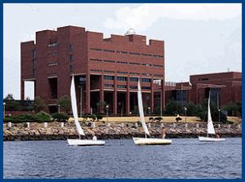
Joseph P. Healey Library, University of Massachusetts, Boston
Faculty and students returning to the University of Massachusetts (UMass) Boston campus for the Spring 2017 semester will encounter a library with resources noticeably reduced thanks to dramatic budget cuts. On November 10, 2016, an email notified the UMass Boston community of budget cuts for Fiscal Year 2017, including roughly 20 percent of the Healey Library’s general operating fund, amounting to approximately $700,000.
The timing of the announcement—after the majority of the library’s electronic resource subscription contracts for 2017 had already been renewed—placed the library in a challenging position, forcing it to cancel those resources with soon-to-expire subscriptions, abandoning many useful and needed resources. A notice on the library website advises the campus community that “these non-renewal decisions were driven entirely by the delivery date of the budget cuts memo and by the renewal queue of the Library’s electronic resources.”

http://lj.libraryjournal.com/2017/01/academic-libraries/umass-boston-library-cuts-squeeze-resources

Practical Research, Practical Marketing
Posted on January 26, 2017 Leave a Comment
What’s the secret to helping your faculty produce academic research that resonates with practitioners, students, policy makers, and other influencers?
Think less about theory, and more about practical relevance—that’s the opinion of Thomas W. Kent, Ph.D., professor and chair for the Department of Management and Entrepreneurship, School of Business, College of Charleston. “I think there’s a huge gap between what authors write about and what practitioners are interested in.”
Having served at the executive levels of two global corporations and the one-time owner of a firm that consulted internationally on the subject of organizational excellence and productivity, Kent spoke recently about the topic of relevant research at the Charleston Conference, on a panel titled, “Research in the real world: accessibility, nurturing usage, and turning theory into practice.”
Kent’s research includes areas of leadership, teams, and organizational productivity, and he begins each project by evaluating whether the end product is sell-able, not just from a monetary standpoint, but ideologically. As simple as it sounds, he starts by asking the question, “to managers who are in the position to purchase this research, how useful will this be to them?”

http://lj.libraryjournal.com/2017/01/academic-libraries/practical-research-practical-marketing/?utm_source=ljnewsletter&utm_medium=newsletter&utm_content=sponsoredcolumn&utm_campaign=emerald

A Unified Voice: Confronting an Assault on Information | Editorial
By Rebecca T. Miller on January 31, 2017 Leave a Comment
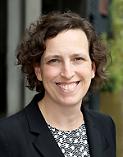I wrote recently that the rate of media illiteracy is the information crisis of our time (“Faked Out”), but now that very real issue has nonetheless been trumped by a deliberate assault on the flow of information—from journalism and scientific research to dissemination via social media and traditional channels. There is no such thing as an alternate fact, but there is certainly an alternate reality: a chilling, censorial, obfuscating one being offered as a threatening new normal by the new federal administration in the first days and weeks of 2017.
These encroachments are sparking vocal outrage from many. They should have everyone in the library community on high alert. Information, and the ability to share it without risk of retribution, is central both to our work in libraries and the democratic process as a whole.
These events should clarify things for anyone who doesn’t see the library connection. This is not a partisan issue; it is about information access and defending a culture that celebrates and benefits from the robust discourse possible only when information and ideas can be shared openly. That seems so obvious that the need to state it is disturbing to me. Our work to protect freedom of inquiry and expression is never done, but it is more critical than ever in this heated and rapidly evolving environment.

http://lj.libraryjournal.com/2017/01/opinion/editorial/a-unified-voice-confronting-an-assault-on-information-editorial/

Rethinking the What and How of the ILS
Posted on January 19, 2017 1 Comment
by Tania Fersenheim, Content & Applications Manager at Fenway Libraries Online
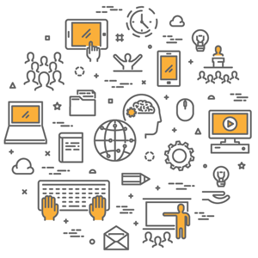
Are we spending money wisely? Librarians and administrators ask themselves this question in many ways, both big and small, every day. Sometimes it keeps us up at night. It’s inherent in the choices we make between different brands of dry erase marker, different resources covering the same subject area, and in decisions to implement or replace software that helps us do our jobs.
Libraries are asked more and more to justify the dollars we spend, and many of us are investing time and money in analyzing usage data, assessing the effectiveness of instruction programs, and otherwise attempting to quantify the return on our investment of the institution’s money.
A colleague used the word “brobdingnagian” in casual conversation the other day, and it struck me again how apt the term is in describing current ILS industry trends. I am not alone in noting that Alma and WMS, the top contenders among ILSes, are moving us back in the direction of gigantic one-stop-shopping library management systems, after a couple of decades of external solutions popping up to fill the emerging needs unmet by the ILS — eResource management, federated search, subject guides, data warehousing/reporting, and even discovery.

http://lj.libraryjournal.com/2017/01/library-services/rethinking-the-what-and-how-of-the-ils/

Placemaking and the Public Library | ALA Midwinter 2017
By Stephanie Sendaula
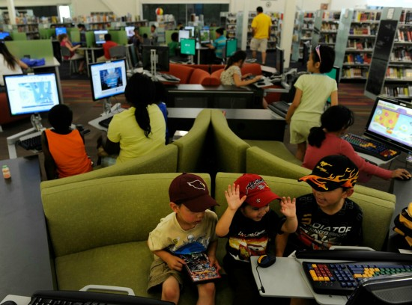
Photo credit: Denver Public Library
“People crave community. Community needs space. Space can create community. If you are not creating community, you are probably not creating places,” explained Michelle Jeske, City Librarian at Denver Public Library (DPL) and a 2005 LJ Mover & Shaker, to an eager crowd gathered for Placemaking and the Public Library on Sunday, January 22.
What is placemaking? Jeske defines it as the process of re-imagining and re-envisioning public spaces. There were nods of agreement when she continued, “Look at how people are improvising in a space. You’ve all seen this in your library, where people are, every day, moving the chairs around. They’re telling you something… and we should be paying attention to [it].”
Acknowledging that funding is a primary concern for public libraries, Jeske suggests creating a place, not a design. How can you do this at your library? Start small. Begin with observing, listening, and asking. Here are several of Jeske’s budget-friendly examples of refitting space to meet community needs.
- Rearrange tables or chairs. This is a low-cost way to change how people interact with and within a library.
- An extra pack of Post-It notes led the DPL staff to develop this idea: Take a Kind Note, Leave a Kind Note. Besides being affordable, it’s been popular among patrons.
http://lj.libraryjournal.com/2017/01/shows-events/ala/placemaking-ala-midwinter-2017/

7.
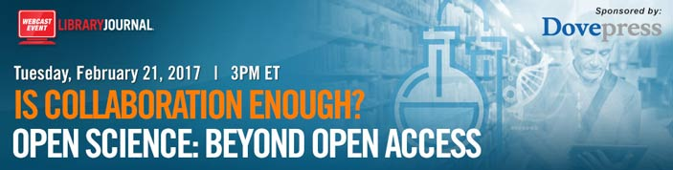

Open Science: Beyond Open Access
Tuesday, February 21, 2017
3-4 PM ET, 12-1 PM PT
Collaboration can be a major driver for success. When data is shared among researchers, analysts and stakeholders, the opportunities for innovation and development increase exponentially, particularly in the medical and science fields. To be most effective, the Open Science framework demands more than simply sharing data--it requires dedication, transparency and responsible publishing.
Join this webcast to learn from our panel of experts as they discuss the challenges and benefits of Open Science in the context of global health and medical concerns. They will explain how the disruptive concept of Open Data can reshape and improve the nature of research and results

