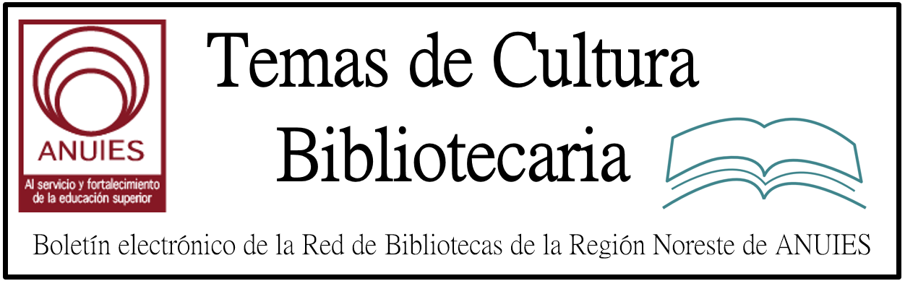

Año 2 Número 13 Febrero 2017

Contenidos de este número

- Curso/Taller sobre Direccion y Desarrollo de Recursos Humanos en Organizaciones Bibliotecologicas - IIBI UNAM Mexico

El Instituto de Investigaciones Bibliotecológicas y de la Información de la Universidad Nacional Autónoma de México le invita cordialmente al
CURSO/TALLER SOBRE DIRECCIÓN Y DESARROLLO DE RECURSOS HUMANOS EN ORGANIZACIONES BIBLIOTECOLÓGICAS
Que será impartido por el Dr. Federico Hernández Pacheco, Investigador del IIBI UNAM.
Objetivo General:
Identificar las diferentes tendencias y funciones de los recursos humanos en organizaciones públicas o privadas y su aplicación en organizaciones bibliotecológicas.
Dirigido a:
Profesores, investigadores y profesionales con estudios de licenciatura en Bibliotecología, Biblioteconomía, Ciencias de la Información Documental y áreas afines, interesadas y vinculadas con los recursos humanos o manejo de personal.
Temario:
Consulte el temario completo del Curso/Taller en: https://goo.gl/DiRntK
Requisitos:
- Enviar ficha de registro con copia de titulo, cedula profesional, carta de pasante o certificado de estudios en las carreras mencionadas (sin estos requisitos, no se aceptara la inscripción y el registro al curso).
El Curso/Taller se llevara a cabo del 27 al 31 de marzo de 2017, en la Sala de Seminarios 2 del IIBI, ubicada en la Torre II de Humanidades piso 13, Ciudad Universitaria, Coyoacán, Ciudad de México.
Horario: 16:00 a 20:00 hrs.
Duración: 20 horas

2.
Drexel University’s nationally-ranked online Master of Science in Library & Information Science (MSLIS) offers students transformative insight into the future of librarianship.

Taught by the College of Computing & Informatics faculty, Drexel’s online MSLIS offers students the knowledge and skills they need to help their communities access and use information more efficiently and effectively.

Featured online programs:
- MS in Library & Information Science
(Concentrations in Archival Studies, Digital Curation, Digital Libraries, Library & Information Services and Youth Services)
- Post-Master’s Library Specialist programs
(In Archival Studies, Digital Curation, Digital Libraries and Youth Services)

ALA Member Benefits:
- New student partner rate - 10-40% tuition savings
- Apply online at no cost, deferred billing options available
- Dedicated support from enrollment to graduation
- Additional benefits for military servicemembers, veterans and their immediate family
Learn More

http://duo.online.drexel.edu/mslis/?campaign=140196&ccid=140196&wt.mc_id=140196&utm_source=Library+Journals%2C+LLC&utm_medium=email&utm_content=MS+in+LIS&utm_campaign=140196

3. Carnegie Medals, Notable Books List Announced |

ALA Midwinter 2017
BY BARBARA HOFFERT ON JANUARY 23, 2017 LEAVE A COMMENT
Winners of the Andrew Carnegie Medals for Excellence in Fiction & Nonfiction were announced on Sunday, January 22, at the Reference and User Services Association’s (RUSA) Book and Media Awards Ceremony at the America Library Association’s Midwinter Meeting & Exhibits conference in Atlanta. The fiction medal winner is Colson Whitehead’s The Underground Railroad (Doubleday), a searing reimagining of slavery in the antebellum South that also won the National Book Award. The nonfiction medal winner is Matthew Desmond’s Evicted: Poverty and Profit in the American City (Crown), a chronicle of two landlords and several struggling families in Milwaukee that highlights the dangers of those sliding into homelessness in America today. Both books were LJ Best Books.
The Notable Books List, an annual list of best adult titles published in the United States and including literary fiction, nonfiction, and poetry, was also announced at the ceremony. The fiction list was distinguished by several outstanding debuts, including Nathan Hill’s The Nix (Knopf), an LJ Best Book; Yaa Gyasi’s Homegoing (Random), winner of the National Book Critics Circle’s John Leonard Prize; Max Porter’s Grief Is the Thing with Feathers (Graywolf), a Dylan Thomas Prize winner that also received multiple awards short-listings; Shoba Rao’s An Unrestored Woman (Flatiron), a distinctively structured story collection; Iain Reid’s I’m Thinking of Ending Things (Scout: Gallery), well-wrought suspense about a man who abandons his girlfriend on a drive to see his parents; Tim Murphy’s Christodora, a multilayered look at New York City over time; and Imbolo Mbue’s Behold the Dreamers (Knopf), the affecting story of an immigrant couple. Whitehead’s Carnegie Medal winner, The Underground Railroad, also made the list.

http://reviews.libraryjournal.com/2017/01/prepub/carnegie-medals-notable-books-list-announced-ala-midwinter-2017/

4. Publishing for Librarians’ Changing Needs
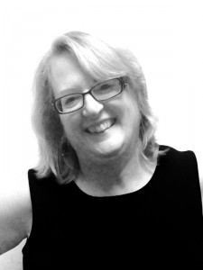Patti Davis thinks of her job as publisher for Emerald Publishing in terms of a mission.
“We have a mission to publish research that is applicable to the real world,” she says. “More and more, society is looking for research that is real for their experience, helpful for their day to day life, and their work life.”
It’s an area where Davis sees challenges. Speaking at a recent conference in South Carolina, she cited a study from International Journal of Operations & Production Management, where senior researchers were asked to read samples of the most downloaded research articles. Turns out they were of very little use.
The problem? In Davis’ estimation, obtuse writing, written from the “Ivory tower.”

http://lj.libraryjournal.com/2017/01/academic-libraries/publishing-for-librarians-changing-needs/?utm_source=ljnewsletter&utm_medium=newsletter&utm_content=sponsoredcolumn&utm_campaign=emeraldpublishing

5. NYPL, Macmillan Launch Publishing Partnership
By Henrietta Verma
Will Schwalbe
Photo credit: Josef Astor
New York Public Library (NYPL) and big-five publisher Macmillan have reached an agreement that will see Macmillan release children’s and adult print and ebooks inspired by and sourced at the library, making NYPL’s famed collection available to a broader audience. Adult works will be overseen by St. Martin’s Press executive editor Michael Flamini, while publisher Jean Feiwel and Henry Holt Books for Young Readers editorial director Christian Trimmer will oversee the children’s part of the program. “This partnership with Macmillan is a new, wonderful way to share our collections and celebrate the role of libraries with the public, said NYPL President Tony Marx. Macmillan expressed similar pleasure, with CEO John Sargent commenting, “What a great pleasure it is to be the publishing partner of the NYPL…It is an honor both personally and professionally to work with them to disseminate this great wealth of content.”
http://lj.libraryjournal.com/2017/01/publishing/nypl-macmillan-launch-publishing-partnership/

6.
Get ahead of the game.

Library Journal and BiblioBoard partner to bring you SELF-e, your library's solution to becoming a community center for local author discovery. SELF-e's mission is to make your library a hub for patrons to connect with indie and self-published authors in your community.
If you're ready to learn more about the best practices for supporting local indie authors, SELF-e is proud to provide you with this complimentary download of "Five Crucial Mistakes Libraries Should Avoid with Self-Publishing: A SELF-e White Paper."
You can expect more evidence-based insights like these from SELF-e's white papers throughout 2017. We look forward to helping your library make informed decisions about the best ways to connect local authors and patrons at your library.

http://mediasource.actonservice.com/acton/ct/10574/s-0f2b-1701/Bct/l-00ab/l-00ab:22523/ct3_0/1?sid=TV2%3A8xOfgbdfK

7. Libraries Held to Ransom
BY ANNOYED LIBRARIAN
The ALA Midwinter Meeting in Atlanta is winding down now, and it will probably be best remembered as the ALA during which 60,000 people joined the Women’s March in the conference city after the inauguration of President Trump. There were a lot of librarians wearing pink hats marching through the Atlanta streets in protest.
That’s the kind of thing to be expected, though. In much weirder news, the “St. Louis Public Library computer system has been hit with a ransomware attack.”
I hate to admit that I was naive enough not to know what a ransomware attack was. In this case, it means “a hacker organization has blocked their server and is demanding tens of thousands of dollars to release their computers back to them.”
If that kind of news makes you wonder what sort of world we’re living in, see paragraph one.
But seriously, what kind of hackers decide to hold a public library to ransom?

http://lj.libraryjournal.com/blogs/annoyedlibrarian/2017/01/23/libraries-held-to-ransom/

