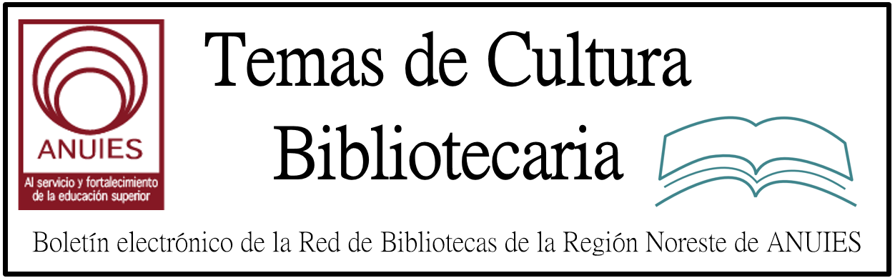

Año 2 Número 12 Febrero 2017

Contenidos de este número

Saskatoon Library Launches Read for Reconciliation Space
By Lisa Peet on January 5, 2017 Leave a Comment
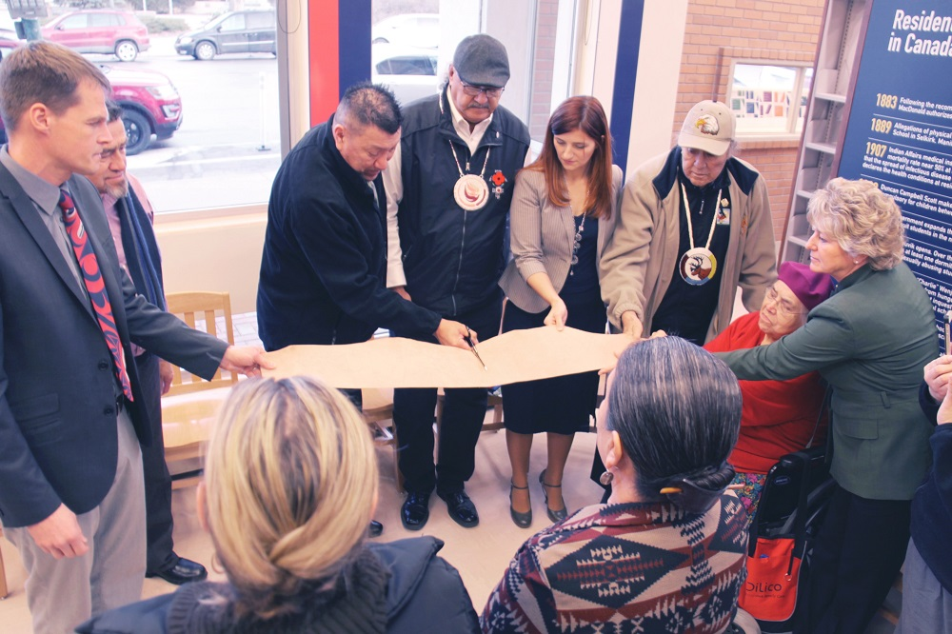
Hide cutting at opening of SPL’s Reconciliation Reading Area (l-r): Saskatoon Mayor Charlie Clark, Office of the Treaty Commissioner, Executive Director Harry Lafond, Kelly Bitternose (survivor), Eugene Arcand, SPL Board Chair Candice Grant, Elder Walter Linklater, Elder Maria Linklater and Carol Cooley CEO and Director of Libraries for Saskatoon Public Library.
Photo credit: Eagle Feather News
Since the last of Canada’s Indian residential schools closed in 1996, the nation has been attempting to shape a response to the legacy of abuse that the residential school system—which removed native children from their homes and families—inflicted on its Indigenous Peoples. The Truth and Reconciliation Commission of Canada (TRC), established in 2008, spent seven years assembling documentation from survivors and working to build awareness of these abuses, ultimately issuing a series of Calls to Action at the end of 2015. Since that time a number of institutions have implemented programs to advance the national movement toward reconciliation, including the establishment in 2015 of the National Centre for Truth and Reconciliation (NCTR), hosted by the University of Manitoba, Winnipeg. In February 2016 the University of Saskatchewan joined eight other post-secondary institutions in partnership with NCTR to make some five million electronic records on the subject accessible.
Now Saskatoon Public Library (SPL), Saskatchewan, has become the first public library to incorporate a space permanently dedicated to truth and reconciliation. On November 21 SPL’s Frances Morrison Central Library opened the Read for Reconciliation reading area, which includes a full set of the reports compiled by the TRC over five years, plus a variety of books about Canada’s history of residential schools, as well as an extensive reading list on the history and legacy of residential schools in Canada on its homepage.

http://lj.libraryjournal.com/2017/01/academic-libraries/saskatoon-library-launches-read-for-reconciliation-space/#_

WhiteSpace Project Could Grow Rural Broadband Access
By Matt Enis
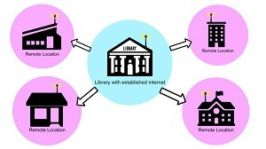Leveraging TV white space (TVWS)—unused, license-exempt portions of the radio spectrum that have been traditionally allocated to television broadcasters—could expand broadband Internet access in rural areas. The San José State University (SJSU) School of Information, in partnership with the Gigabit Libraries Network(GLN), has been assessing ways to do so through the Libraries WhiteSpace Project.
As a secondary goal the project, which recently was awarded a National Leadership Grant of nearly $250,000 from the Institute of Museum and Library Services (IMLS), also aims to evaluate how public libraries and other Community Anchor Institutions (CAIs), such as schools and hospitals, might provide TVWS-based Wi-Fi access as a component of local disaster response. Additional partners include the Schools, Health and Libraries Broadband Coalition (SHLB), National Digital Inclusion Alliance (NDIA), and Information Technology Disaster Resource Center (ITDRC).

http://lj.libraryjournal.com/2017/01/industry-news/whitespace-project-could-grow-rural-broadband-access/

- Jill Bourne: LJ’s 2017 Librarian of the Year

Jill Bourne: LJ’s 2017 Librarian of the Year

City Librarian, San José, CA
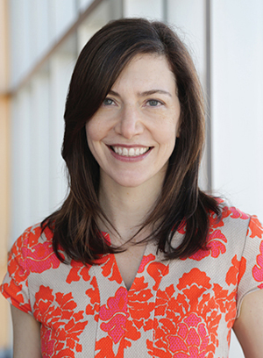When she arrived to direct California’s San José Public Library (SJPL) in 2013, Jill Bourne faced the effects of years of decimating budget shortfalls and service cuts. The system’s 23 branches had all been built or renovated in a previous and generous capital improvement program, but several of the new buildings were already shuttered. In the rest, hours had been reduced to four days per week. Library use was in a steep decline.
The effectiveness with which Bourne spearheaded her Library Access Strategy, opened the libraries, built new relationships with and support from San José’s civic leadership, and leveraged partnerships and fostered innovation—and is now reaching beyond the library to a new citywide Education and Digital Literacy Initiative—has won over a newly inspired staff and convinced our judges to name her the 2017 LJLibrarian of the Year, sponsored by Baker & Taylor.
http://lj.libraryjournal.com/2017/01/managing-libraries/jill-bourne-ljs-2017-librarian-of-the-year/

Libraries Join National Initiative To Transform Public Housing into Book-Rich Environments
By Christina Vercelletto on January 9, 2017 Leave a Comment
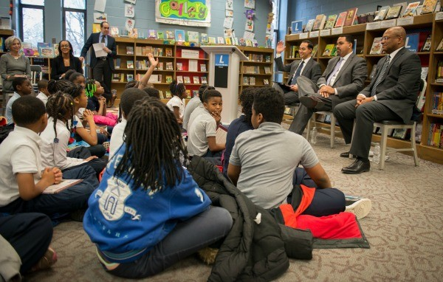
Students interact with, from left, Julián Castro, John B. King, Jr., and Broderick Johnson at the Washington DC Southwest Public Library during the announcement of the Book-Rich Environment Initiative.
The Book-Rich Environment Initiative, designed to boost literacy and improve educational outcomes for public housing residents, has been launched. The announcement was made by Julián Castro, secretary, U.S. Department of Housing and Urban Development (HUD); John B. King, Jr., secretary, U.S. Department of Education; and Broderick Johnson, chair of My Brother’s Keeper Task Force and assistant to the President, on January 5 at the Washington, DC Southwest Public Library.
The primary goal of the initiative is to bring free, diverse, high-quality books and other literacy tools to families living in HUD-assisted housing, home to nearly four million children.
The work will be done in partnership with public library branches, which will distribute the books. Each library will receive a set of books from the National Book Foundation, which will be donated by publishers. Penguin Random House is contributing 200,000 books; Hachette Book Group and Macmillan Publishers are also making large donations. The number of books in each set will depend both on the needs of the housing community being served, as well as the capacity of that particular local library to process the books.

http://www.slj.com/2017/01/industry-news/libraries-join-national-initiative-to-transform-public-housing-into-book-rich-environments/#_

5.Curso: Taller de Digitalización de Archivos
Objetivos:
Conocer, identificar y comprender los fundamentos, elementos, técnicas e instrumentos que intervienen en el proceso de digitalización de documentos, para su uso, conservación y difusión.
Temario:
1. Hardware / Software para la Digitalización
2. Imagen Digital
3. Tecnologías de Aplicación
4. Archivos Gráficos
5. El Proceso de la Digitalización de Documentos
6. Sistemas de Gestión Documental

6.
How is the library shaping Open Access?
And how is Open Access shaping the library?
Revamped and expanded for 2017, Open Access in Action offers a new array of video interviews, webcasts, and informative articles. Whether your interest is funding, support, advocacy, or the open science movement, stay in touch with how professionals like you are shaping practice.
Visit the new site or follow us on Twitter to be the first to know when new content goes live or when new webcasts have been announced.

http://lj.libraryjournal.com/openaccessinaction/?ref=oaia-promoblast
http://imac.us8.list-manage.com/track/click?u=a77c14c168209790a5a4a294e&id=38441799ef&e=451275960b

7. Navajo Nation Library To Digitize 1960s Oral History Archive
By Lisa Peet
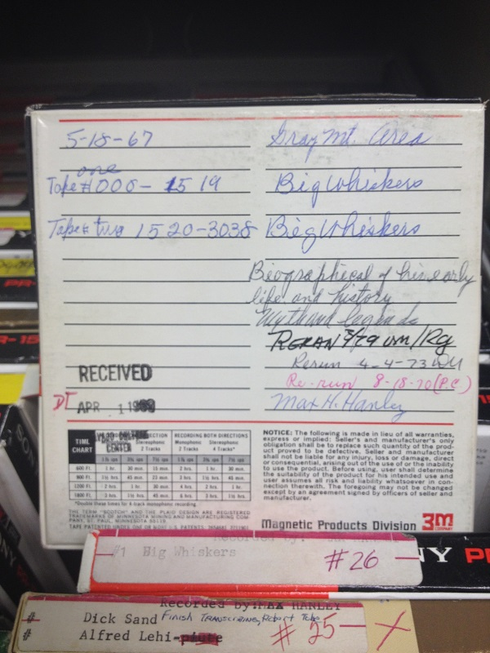
Sample tape from NLL oral history collection
Photo credit: Irving Nelson
The Navajo Nation Library (NNL) is working to secure the funding necessary to digitize and catalog thousands of hours of stories, songs, and oral histories of the Navajo people, originally recorded in the 1960s by the Navajo Culture Center of the Office of Navajo Economic Opportunity (ONEO).
The tapes hold personal accounts by Navajos of their daily lives in the rural towns of the Navajo Nation, as well as songs, legends, stories, and religious music, including a recording of the sacred nine-night ceremony.
The collection of 300 reel-to-reel tapes was acquired by the NNL in the late 1970s, after they were discovered in storage in an unused Fort Defiance, AZ, jail cell. Although the tapes were assessed in 2007 and found to be still viable, they are extremely fragile. The digitization process needs to happen as soon as possible, says NNL program supervisor Irving Nelson, as it is only a matter of time until they deteriorate to the point where they can’t be transferred to another medium.

http://lj.libraryjournal.com/2017/01/digital-content/navajo-nation-library-to-digitize-1960s-oral-history-archive/

7. Patrons Less Aware of How Libraries Are Used
November 17th, 2016
It’s no surprise that libraries are acutely aware of changes in how their institutions are used: Keeping accurate records helps them advocate for more resources and determine how those resources should be allocated. Patrons, however, do not always know about these shifts in usage, and that can be problematic in getting them to advocate for the library.
In a recent survey conducted by McGraw-Hill Education, librarians were asked to rate the most important need their library fulfills in their community.
- 43% of librarians said “access to information”
- 34% said “access to technology”
- 10% said “research opportunities”
- 27% said “services and programs”
- 15% said “space to study and collaborate”

http://mcgrawhillprofessionalblog.com/patrons-less-cognizant-libraries-used/

