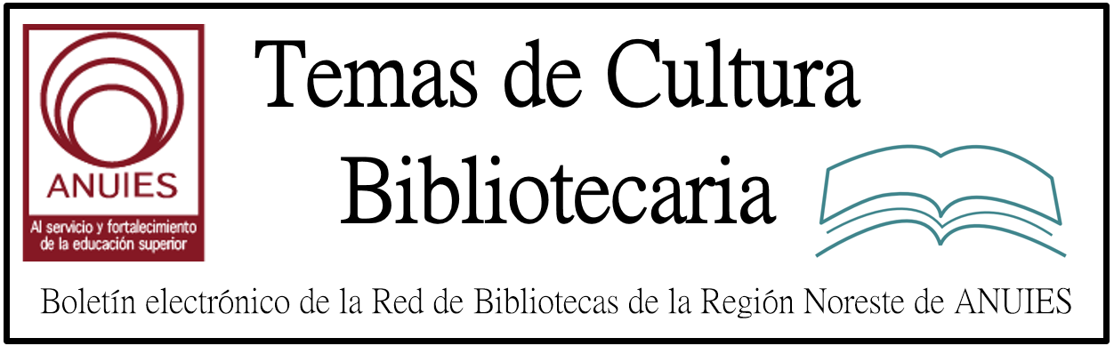

Año 2 Número 10 Enero 2017

Contenidos de este número

- Geeking Over Google and eBooks
Now Available Free On Demand!
Meeting the research needs of the 21st century library patron isn’t the simplest of endeavors. You have to make sure your collection is current and authoritative, yet comprehensive. But, aren’t you running out of shelf space? And do your patrons even know of the resources and tools you have available online, and the benefits of using them?
“Geeking over Google and eBooks” will highlight the benefits of integrated collaboration tools available to your patrons through Gale eBooks on GVRL. Katrina Stokes, Director at Warren County-Vicksburg Public Library (MS) discusses how collaboration features, such as Google Apps for Education tools like Drive and Docs, changed how her library provides and promotes their reference content.
Listen to Katrina as she recalls personal patron accounts of GVRL successes like providing homework help and supporting test prep for people entering the military. Through expanded access and discovery, Gale eBooks on GVRL can increase shelf space, decrease costs, and empower your patrons.

The Smell Test: Educators can counter fake news with information literacy. Here’s how.
By Linda Jacobson on January 1, 2017 3 Comments
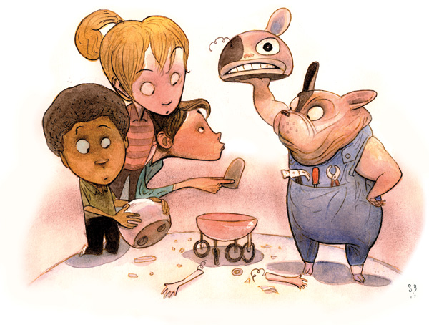
Illustration by Steve Brodner
Discerning fact from fiction in news and online content has never been more challenging. From “pizzagate”—false reports of a child sex ring operating in a DC pizza parlor—and creepy clown attacks to retweeted election headlines touting events that never happened, fake news is rampant. Twenty-three percent of Americans say they have shared fabricated reports, knowingly or not, according to a December Pew Research Center report.
Librarians have an opportunity to take leadership in the current crisis. As proven authorities on information literacy, library professionals can help students analyze news authenticity. It’s time to step up to the plate.
That requires expertise—and perseverance. While school librarians are updating lessons on news literacy, a recent study from researchers at Stanford University underscored the challenges of media and social media education for kids. Students’ ability to evaluate information on the Internet is “bleak,

http://www.slj.com/2017/01/industry-news/the-smell-test-educators-can-counter-fake-news-with-information-literacy-heres-how/

New database to track millions of public policies
Policymakers, researchers and journalists alike will soon have access to roughly 4.2 million state government decisions in a single database.
West Virginia University political science researcher, William Franko, a professor in the Rockefeller School of Politics and Policy, is part of a research team collecting every legislative bill, executive rule and judicial decision across all 50 states, some dating back to the 1950s.
Over the next three years, the policies will be collected, digitized and compiled in an open source database. The first-of-its-kind database will serve as a comprehensive source of data to track the movement of policies from one state government to another.
http://eberly.wvu.edu/news-events/eberly-news/2016/12/20/new-database-to-track-millions-of-public-policies

Principio del formulario
Final del formulario

Matt Sessa, Deputy Chief Operating Officer, Federal Student Aid
Subject: Federal Student Aid Posts Updated Reports to FSA Data Center
Today, Federal Student Aid posted a series of updates to its FSA Data Center, the centralized online source for Federal Student Aid data. In addition to posting updates to the quarterly application, disbursement, and portfolio reports, Federal Student Aid released a preliminary report regarding the complaints, positive feedback cases, and allegations of suspicious activity received through its FSA Feedback System and added three new reports related to the federally managed portfolio and one new report about the Teacher Loan Forgiveness (TLF) Program.
https://ifap.ed.gov/eannouncements/122016FSAPostsUpdatedReportstoFSADataCenter.html

Researchers model how ‘publication bias’ does — and doesn’t — affect the ‘canonization’ of facts in science
James Urton

Carl Bergstrom believes facts stand a fighting chance, especially if science has their back. A professor of biology at the University of Washington, he has used mathematical modeling to investigate the practice of science, and how science could be shaped by the biases and incentives inherent to human institutions.
“Science is a process of revealing facts through experimentation,” said Bergstrom. “But science is also a human endeavor, built on human institutions. Scientists seek status and respond to incentives just like anyone else does. So it is worth asking — with precise, answerable questions — if, when and how these incentives affect the practice of science.”
In an article published Dec. 20 in the journal eLife, Bergstrom and co-authors present a mathematical model that explores whether “publication bias” — the tendency of journals to publish mostly positive experimental results — influences how scientists canonize facts. Their results offer a warning that sharing positive results comes with the risk that a false claim could be canonized as fact. But their findings also offer hope by suggesting that simple changes to publication practices can minimize the risk of false canonization.

http://www.washington.edu/news/2016/12/20/researchers-model-how-publication-bias-does-and-doesnt-affect-the-canonization-of-facts-in-science/

Have you experienced the new OverDrive yet? It’s the easiest, fastest way to reading happiness from your library. It offers simple, powerful tools to deliver the eBooks and audiobooks your patrons want. And it’s also been designed to help them discover new content they’ll love from your library.

Some of the great features you’ll find:
- Auto-complete search
- Recommendations
- Fast, simple user experience
- Focused search filters
- Adjustable lending periods & maturity levels
- More options for signing in
- And more

Experience the new OverDrive for yourself

https://www.overdrive.com/

Libraries Nationwide Seek to Foster Dialog
By Julia Marden
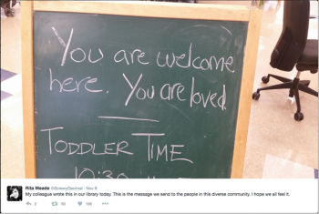
Message at Bay Ridge branch of Brooklyn Public Library
In the weeks since the 2016 presidential election, librarians across the United States have taken actions to foster dialog, confront intolerance, and reaffirm public libraries as safe spaces for all patrons. Whether as a reaction to the need to initiate community conversations or as a response to incidents taking place within the library, library employees are looking at ways to get people talking—and listening.
TELLING ELECTION STORIES
After the election Robyn Case, adult services librarian at the Wright Memorial Public Library (WMPL) in Oakwood, OH, felt that she, along with the library’s patrons, were trapped in a filter bubble that prevented them from perceiving one another’s differences in opinion. On November 9, Case launched an oral history project to capture patrons’ responses to the election, putting out a call for community members to come to the library and contribute their stories.
Case pulled together the oral history project quickly. “I launched it pretty spontaneously the day after the election results,” she told LJ. “I just needed something to do because I was pretty surprised and taken off guard. I think it was for me a way to understand.”

http://lj.libraryjournal.com/2016/12/library-services/libraries-nationwide-seek-to-foster-dialog/

