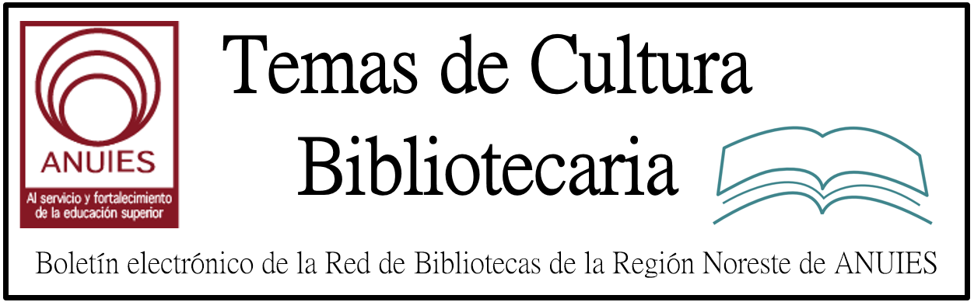

Año 1 Número 8 Diciembre 2016

Contenidos de este número

Snapchat in the Library

Librarians master an app to reach millennials
By Paige Alfonzo | November 1, 2016
Some of the entries in Nashville (Tenn.) Public Library's Geofilter design contest for teens.
Much has changed in the five years since Snapchat arrived on the social media scene. It’s no longer the fledgling “disappearing message app” used solely by teens. Snapchat is now the poster child for message-focused social media apps that are growing in popularity among young users. It’s a platform that emphasizes interaction, capitalizing on the playful side of social media and providing a way for users to send multimedia messages (“snaps”) back and forth between friends.

https://americanlibrariesmagazine.org/2016/11/01/snapchat-in-the-library/

- Libraries Test Chronicle: Collaborative Local History
By Jennifer Koerber

Chronicle ScreenshotWhen libraries seek community help with local history/photography projects, one of the most challenging details is often finding a user-friendly tool for the job. The team behind Chronicle—a new collaborative platform and community designed for photographers—has approached several libraries over the past six months to participate in the closed beta release of the platform. Users add recent photos or scanned archival prints to the platform via an app or web interface, where they are collected in chronicles focused on specific locations, events, or themes.

http://lj.libraryjournal.com/2016/12/technology/libraries-test-chronicle-collaborative-local-history/

- Introducing the
Welcome Newcomers Library

Reading Level: 1.6 to 2.5 | Grades: YA | Lexile: 150L to 290L

Topic-Based Books to Help New Immigrants Thrive

The Welcome Newcomers library is a unique instructional solution that introduces life in the United States to immigrant teens. As these students learn English and adapt to living in a new country, they must learn to fit in socially and academically. Developed around 14 topics that are critical to success in American schools and communities, Welcome Newcomers gives recent immigrants relevant information supported by full-color photographs of diverse teens in real-world settings. The program includes nonfiction and fiction books, survival vocabulary cards, lesson plans, reproducible activities, and assessments. Each topic is covered by a pair of books, one nonfiction and one fiction. The 64-page nonfiction and 48-page fiction books feature easy-to-read text and engaging photographs. Welcome Newcomers places special emphasis on building vocabulary, because research indicates the importance of vocabulary acquisition for students learning English. Survival words related to each topic are highlighted in the books, with definitions provided in text boxes on the page for easy reference. These same words are featured on the full-color vocabulary cards included in the box. Featuring diverse characters in contemporary settings, the books resonate with newcomers in secondary and adult programs.

http://www.sdlback.com/newcomer-ell/welcome?utm_content=f1abf0cd659fd791728995be81b1087b&utm_campaign=Welcome%20Consumers&utm_source=Robly.com&utm_medium=email

- 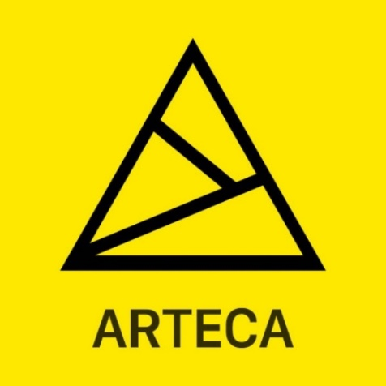
ARTECA is a dynamic space for essential content linking the arts and sciences and technology.

From the MIT Press, ARTECA houses a curated collection of content that explores the myriad ways the arts and sciences and technology connect. Current holdings include 200 books and nearly 500 journal issues, with new content added regularly.
Any library can sign up for a free 60-day trial, complete with customer support and usage reports.

http://arteca.mit.edu/

- Library and Information Science Conference Athens Greece

The Athens Institute for Education and Research (ATINER), a world association of academics and researchers based in Athens, organizes its 4th Annual International Conference on Library and Information Science, 24-25 July 2017, Athens, Greece. You are more than welcome to submit a proposal for a presentation by email to atiner@atiner.com, before 26 December 2016. The registration fee is 540 euro and includes accommodation during the days of the conference, participation to all sessions of the conference, breakfasts, two lunches and all taxes. If you need more information, please let me know and our administration will send it through to you.

info@athensconference.gr
- 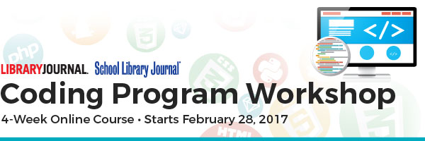
Registration now open for the Coding Program Workshop
We are excited to announce that the second installment of our Coding Program online course will feature all new content to teach you how to launch a coding program in your library that will promote digital literacy and impact your community.
Over four weeks, you will have direct access to live speakers via webcasts and be challenged to complete assignments and field research that will result in a complete understanding of how to run computer programming courses that will introduce your patrons to new career paths and technologies.

