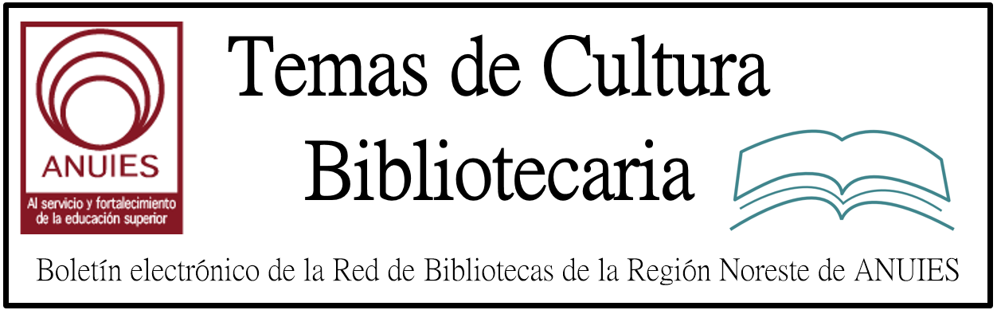

Año 1 Número 7 Diciembre 2016

Contenidos de este número

1 ICDL 2016
Smart Future: Knowledge Trends that will Change the World
13-16 December 2016, India Habitat Center, New Delhi, India
Three days of deliberations and discussions in the ICDL 2016 workshops will take place at India Habitat Center, New Delhi with innovative cutting-edge learning and engagement opportunities with expert-Led Panels from the industries and academics.
WHAT TO LEARN: BIGDATA & SOCIAL MEDIA ANALYTICS, KNOWLEDGE & INNOVATION MANAGEMENT ? TOOLS, STRATEGIES, BUSINESS APPLICATIONS,
AND MORE?
For further details please log on to the website at www.teriin.org/events/icdl.

2. https://issuu.com/conricyt_noticias/docs/conricyt_5

https://www.ambac.org.mx/jmb48/styled/index.html

https://creativecommons.org/

- As the European Parliament starts discussing copyright proposal, rightsholders point out they want even worse © rules
December 2, 2016 — Paul Keller
Earlier this week the JURI committee of the EP held the first hearing on the proposed Copyright in the Digital Single Market directive. This hearing officially kicks off the process through which the European Parliament will develop its position on the Commission’s proposal. The parliamentary process is shepherded by MEP Therese Comodini Cachia (EPP, Malta). According to a preliminary timelinepublished by her, the process will be completed before next year’s summer break.
http://www.communia-association.org/2016/12/02/european-parliament-starts-discussing-copyright-proposal-rightsholders-point-want-even-worse-rules/

https://issuu.com/conricyt_noticias/docs/conricyt_5

https://issuu.com/conricyt_noticias/docs/conricyt_5

