Año 1 Número 4 Noviembre 2016

Contenidos de este número

Picturing the Library as Public Space
Elizabeth Felicella spent five years documenting how libraries reflect and shape their communities and times.
JESSICA LEIGH HESTER
http://www.citylab.com/navigator/2016/10/images-of-new-york-city-public-libraries/501731/?utm_source=nl__link6_100616

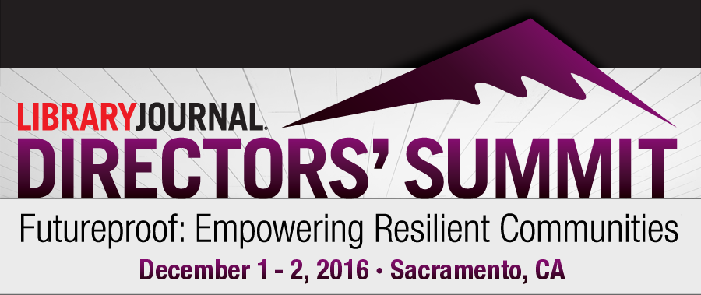

The 2016 summit, Futureproof: Empowering Resilient Communities will focus on sustainability in its most expansive sense. This key group of leaders will grapple with how to use this vital institution—the library—as a driver of community-wide sustainability to ensure a robust local future in the face of historic challenges from climate warming, political swings, and rapidly changing demographics. Set in Sacramento in partnership with Sacramento Public Library, led by the innovative Rivkah Sass, LJ‘s 2006 Librarian of the Year, the high-engagement event will tap on innovators in corporate environments who are reinventing their businesses’ approach to deep sustainability, and explore library-led strategies to design a more dynamic, flexible, and responsive future—one that’s sustainable for themselves and their cities and towns large and small. In its eighth year, this intimate two-day think tank gathers 100+ library leaders and strategic thinkers from beyond libraries to rethink, reengage, and reposition their libraries as futureproof, and primary drivers of futureproof communities.
http://lj.libraryjournal.com/directors-summit/#_

- Jenna Hartel | LJ/ALISE Excellence in Teaching Award Winner 2016

By Lisa Peet on November 16, 2016

On her website, Jenna Hartel talks of “a different character of LIS”—one rooted in positivity, curiosity, and proactivity. While the field has a necessary focus on solutions to information issues, she says, not every transaction need be about problem solving. Instead, interactions can also encompass parallel theories of joyful, playful knowledge seeking. It’s what she calls “the bright side of information,” a focus on the upbeat aspect of library studies that has won Hartel, associate professor on the Faculty of Information at the University of Toronto (U of T), a special spot in the hearts of her students and fellow faculty members—and the 2016 Library Journal/ALISE Excellence in Teaching Award, sponsored by ­Rowman & Littlefield.

http://lj.libraryjournal.com/2016/11/awards/jenna-hartel-ljalise-excellence-in-teaching-award-winner-2016/

- BiblioTech Building Ebook Access by Bus
By Matt Enis on November 18, 2016

BiblioTech KiosksBiblioTech, the digital library of Bexar County, TX, recently added VIA Metropolitan Transit, which provides 39.6 million bus trips annually throughout the county, to a growing list of local partners that help patrons discover and access library ebooks and other content outside of the new system’s two branches. The “Ride & Read” program was launched in September with a new kiosk at VIA’s Centro Plaza hub in San Antonio, and five additional ADA-compliant, wall-mounted screens were installed at hubs throughout the VIA transit network shortly afterward. Using these kiosks, Bexar County residents can register as BiblioTech patrons and then immediately use VIA’s free 4G LTE Wi-Fi—which was expanded to the agency’s entire fleet last fall—to browse and download ebooks, movies, music, and periodicals.

http://lj.libraryjournal.com/2016/11/industry-news/bibliotech-building-ebook-access-by-bus/

- Bibliotecas indígenas latinoamericanas
Daniel Canosa
El presente artículo pretende ofrecer un panorama de los servicios bibliotecarios que se brindan en comunidades indígenas de Latinoamérica. Para tal fin se han examinado las distintas experiencias registradas en la región, conformando un estado de situación de lo que ocurre con la atención bibliotecaria en aquellas comunidades que cuentan con poblaciones aborígenes. La experiencia directa y el contacto personal ha permitido evaluar el real estado de las colecciones, los diferentes servicios ofrecidos a las comunidades, el trabajo interdisciplinario, la vinculación con escuelas que cuentan con Educación Intercultural Bilingüe, los recursos de información y el personal que realiza tareas bibliotecarias en cada comunidad.

https://cf9f25a9-a-62cb3a1a-s-sites.googlegroups.com/site/criticabibliotecologica/final_jnl_of_crit_lib_vol_8_no_15_jul-dec_2016.pdf?attachauth=ANoY7cpXWd3r5Qd1RJAuyGzUuS8_TKqos-wtA9JjWzI_rWszFcc8TNuUNPVRODlnsvM0Yrz9lU5LcIxdShG57o1J3IPXg0in46Wtk4UgzgH_U0rXu62NEcGf1nu6MkRE5QYQIzcseEMkfZx4SVsdgdhe3yNr9hWyCan_ddH_F5RRmnsTcEXdlRRPVW0UfHo6ylQde9UfSC-0RtZajr719ReYerELM1ufRsYMwOTkW4HsPKguZ7b6ah6p-FNM9TmnoI-PHMNLN1SFscvp8PY8SKsjZIOPu9tzLQ%3D%3D&attredirects=0

- Cátedra Libre Bibliotecología Social (CaLiBiSo) en Universidad de Buenos Aires: la extensión universitaria cómo dispositivo de formación en la cooperación y el compromiso
Julio Díaz-Jatuf

Se presenta la experiencia de la Cátedra Libre Bibliotecología Social (CaLiBiSo) de la Facultad de Filosofía y Letras, Universidad de Buenos Aires en relación a su extensión universitaria como dispositivo de formación educativa

https://cf9f25a9-a-62cb3a1a-s-sites.googlegroups.com/site/criticabibliotecologica/final_jnl_of_crit_lib_vol_8_no_15_jul-dec_2016.pdf?attachauth=ANoY7cpXWd3r5Qd1RJAuyGzUuS8_TKqos-wtA9JjWzI_rWszFcc8TNuUNPVRODlnsvM0Yrz9lU5LcIxdShG57o1J3IPXg0in46Wtk4UgzgH_U0rXu62NEcGf1nu6MkRE5QYQIzcseEMkfZx4SVsdgdhe3yNr9hWyCan_ddH_F5RRmnsTcEXdlRRPVW0UfHo6ylQde9UfSC-0RtZajr719ReYerELM1ufRsYMwOTkW4HsPKguZ7b6ah6p-FNM9TmnoI-PHMNLN1SFscvp8PY8SKsjZIOPu9tzLQ%3D%3D&attredirects=0

