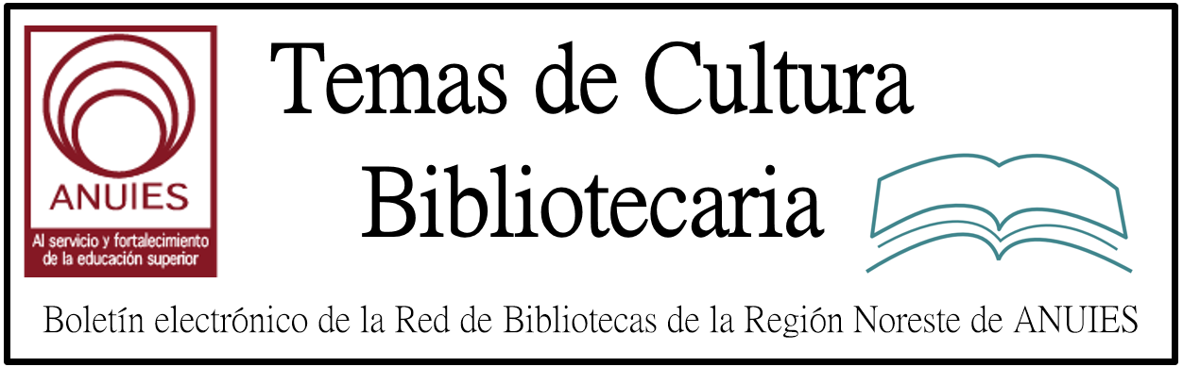

Año 1 Número 2 Noviembre 2016

Contenidos de este número

ODLIS: Online Dictionary of Library and Information Science
http://vlado.fmf.uni-lj.si/pub/networks/data/dic/odlis/odlis.pdf

Más de 13 millones de títulos impresos y digitales, acervo de las bibliotecas de la UNAM

Es mayor al que tiene bajo su cuidado la biblioteca del Vaticano y está cerca del que posee la Universidad de Harvard, señaló Georgina Torres, directora del Instituto de Investigaciones Bibliotecológicas y de la Información

Las 135 bibliotecas a cargo de la UNAM resguardan uno de los acervos más grandes del mundo, compuesto por más de 13 millones de títulos de libros impresos y electrónicos, tesis, DVD y demás materiales de consulta.

http://www.dgcs.unam.mx/boletin/bdboletin/2016_767.html

Pallante Resignation May Indicate New Approach at Copyright Office

By Matt Enis on November 1, 2016 Leave a Comment
U.S. Copyright Office sealOn October 21, Carla Hayden, the new Librarian of Congress, reassigned Maria Pallante, Register of Copyrights and head of the U.S. Copyright Office, to a non-managerial advisory role. On Monday, October 24, Pallante declined the reassignment and resigned from the Library of Congress, effective October 29. Many publishing, music, and film industry groups have expressed surprise at the move, describing it as a firing.

http://lj.libraryjournal.com/2016/11/industry-news/pallante-resignation-may-indicate-new-approach-at-copyright-office/#_

The Right to Link is Challenged Under EU Law

By Kyle K. Courtney

Court of Justice of the European Union main building Photo credit: Transparency International EU Office
Court of Justice of the European Union main building

Now merely linking is under attack?
Watch out, museums, historical societies, archives, libraries, Google, and others! The Court of Justice of the European Union (CJEU), the chief judicial authority of the European Union, on September 8 issued a landmark ruling in a case called GS Media v. Sanoma (C-160/15), concerning hyperlinking and potential copyright infringement

http://lj.libraryjournal.com/2016/11/copyright/the-right-to-link-is-challenged-under-eu-law/

Everything in Its Place | Self-Publishing & Libraries

By Robin Bradford

Sometimes you don’t realize how things are interconnected because you aren’t seeing all parts of the process. That recently happened to me when I started asking catalogers about working with indie titles. The answers I got were surprising.

http://lj.libraryjournal.com/2016/11/industry-news/everything-in-its-place-self-publishing-libraries/

The Oldest Challenge: It comes from believers, parents, even librarians

By John N. Berry III

Conflicts that pit our professional stance in favor of intellectual freedom against citizen pressure or our own impulses to suppress “inappropriate” expression is the oldest challenge librarianship faces. When the modern library movement was born, librarians thought they were gatekeepers. Early debates over whether fiction should be banned ultimately morphed into the profession’s current position: no one has the right to tell anyone else what they are allowed to read.

http://www.infodocket.com/2016/11/02/metadata-2017-mesh-subject-headings-released/

